* CB FSD - Integration and Deployment

Day 1 : 9 July 2024

Docker

Docker compose

CI and CD tool using Jenkin and Jenkin Pipeline

Cloud computing -> S3 and EC2 instance using AWS

Docker : Docker is a platform that is used to containerized our software or application or project, using which we can easily build our application and package them in the form of jar or war file with required dependencies into container and these container are easily shipped to run the our application in another machine.

Container : it is a run time environment.

JRE : Java Run time environment. To run java application.

Node : run time environment. To run angular application

Web Container : web container is a part of web server which is responsible to run servlet and jsp program.

Docker container : it is responsible to run docker images.

Virtualization : Virtualization refer to importing a guest OS on the host or base os system and allowing developer to run multiple OS in different VM while all them run the same host machine. Using virtualization to need to provide any extra hardware as well as recourses. It an use from base OS.

VM ware software.

Virtualization refer to abstract version of an OS.

Containerization : it refer to abstract version of an application.

Containerization also known as abstract version of a virtualization.

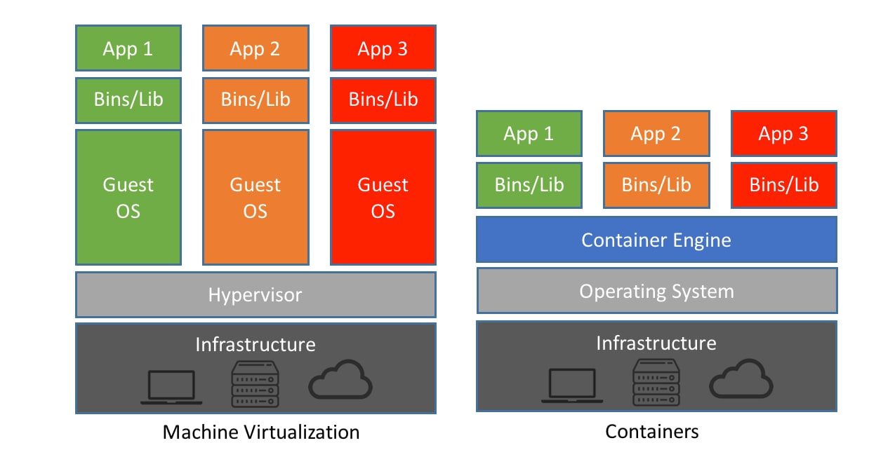

Non window user start with pre-fix sudo

docker --version this command is use to check the docker version

docker info this command provide docker details.

Docker images : Docker image is read only template file which is responsible to run the application with help container.

docker images this command is use to find all images present in our local machine.

docker pull imageName this command is use to pull the image from docker repository by default repository consider as docker hub. Docker hub is a public/private repository which help to publish or push as well as pull the images. It is like a github.

docker pull hello-world

to run the image

docker run imageName/imageId

please signup for docker hub.

pull busy-box image

docker pull busybox

creating custom image

Dockerfile : this file contains set of instruction which help to create the image with help of requirement dependencies.

1. Creating custom image to display message.

**Dockerfile**

FROM busybox

CMD [ "echo","Welcome to Docker Image created by Akash Kale!" ]

docker build -t my-busybox . -f Dockerfile

docker images

docker run my-busybox